Styles

Extension

* Vs code-styled-components
* Prettier - Code Formatter
* CSS peak

import React from 'react';

import styled from 'styled-components';

const Button = styled.button`

 background-color: #007bff;

  color: white;

  border: none;

  border-radius: 4px;

  font-size: 16px;

  cursor: pointer;

  &:hover {

    background-color: #0056b3;

  }

`;

const App = () => (

  <div style={{

    padding: "10px"

  }}>

    <Button>Click Me</Button>

  </div>

);

export default App;

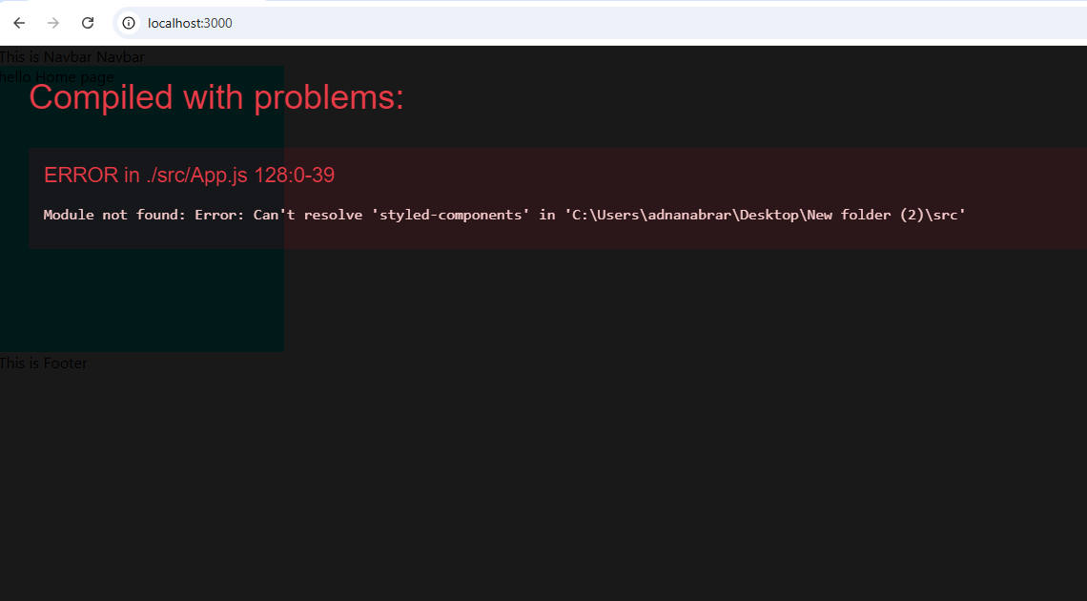

import React from 'react';

import styled from 'styled-components';

const FirstDiv = styled.div`

  background-color: lightblue;

  padding: 20px;

  margin: 10px;

  border-radius: 5px;

`;

const SecondDiv = styled.div`

  background-color: lightgreen;

  padding: 20px;

  margin: 10px;

  border-radius: 5px;

  &:hover {

    background-color: #0056b3;

  }

`;

const Container = styled.div`

  display: flex;

  justify-content: space-around;

`;

const App = () => (

  <Container>

    <FirstDiv>First Div</FirstDiv>

    <SecondDiv>Second Div</SecondDiv>

  </Container>

);

export default App;

**external Style**

styles.css

.home_container {

    background-color: aqua;

    color: black;

    width: 300px;

    height: 300px;

}

import "./components/Styles/styles.css";

import React from "react";

const App = () => (

  <div>

    <div >

      <div className="home_container">hello Home</div>

    </div>

  </div>

);

export default App;

**internal css**

import "./components/Styles/styles.css";

import React from "react";

const App = () => (

  <div>

    <div style={{ padding: "100px" }}>

      <div className="home_container">hello Home</div>

    </div>

  </div>

);

export default App;

**1. SCSS Setup**

React me SCSS use karne ke liye aapko node-sass package install karna padega.

npm install sass

import React from 'react';

import './Header.scss';

function Header() {

  return (

    <header className="header">

      <h1 className="header__title">Welcome to React with SCSS</h1>

      <p className="header__para">Welcome Paragraph</p>

    </header>

  );

}

export default Header;

Header.scss

$primary-color: #3498db;

$secondary-color: #2ecc71;

.header {

  background-color: $primary-color;

  padding: 20px;

  text-align: center;

  &__title {

    color: $secondary-color;

    font-size: 2rem;

    text-transform: uppercase;

  }

  &__para {

    color: $secondary-color;

    font-size: 1rem;

    text-transform: lowercase;

  }

}